💡B.Tech Computer Science and Engineering
Programme Output (POs):
1. Engineering knowledge: Apply the knowledge of mathematics, science,
engineering fundamentals, and an engineering specialization to the solution
of complex engineering problems.
2. Problem analysis: Identify, formulate, review research literature, and analyze
complex engineering problems reaching substantiated conclusions using first
principles of mathematics, natural sciences, and engineering sciences.
3. Design/development of solutions: Design solutions for complex engineering
problems and design system components or processes that meet the specified
needs with appropriate consideration for the public health and safety, and the
cultural, societal, and environmental considerations.
4. Conduct investigations of complex problems: Use research-based knowledge
and research methods including design of experiments, analysis and
interpretation of data, and synthesis of the information to provide valid
conclusions.
5. Modern tool usage: Create, select, and apply appropriate techniques,
resources, and modern engineering and IT tools including prediction and
modeling to complex engineering activities with an understanding of the
limitations.
6. The engineer and society: Apply reasoning informed by the contextual
knowledge to assess societal, health, safety, legal and cultural issues and the
consequent responsibilities relevant to the professional engineering practice.
7. Environment and sustainability: Understand the impact of the professional
engineering solutions in societal and environmental contexts, and
demonstrate the knowledge of, and need for sustainable development.
8. Ethics: Apply ethical principles and commit to professional ethics and
responsibilities and norms of the engineering practice.
9. Individual and teamwork: Function effectively as an individual, and as a
member or leader in diverse teams, and in multidisciplinary settings.
10.Communication: Communicate effectively on complex engineering activities
with the engineering community and with society at large, such as, being
able to comprehend and write effective reports and design documentation,
make effective presentations, and give and receive clear instructions.
11.Project management and finance: Demonstrate knowledge and
understanding of the engineering and management principles and apply
these to one’s own work, as a member and leader in a team, to manage
projects and in multidisciplinary environments.
12.Life-long learning: Recognize the need for, and have the preparation and
ability to engage in independent and life-long learning in the broadest.
>AIM:-
Fitness and Calorie Tracker

> Objective:-
1. To understand the daily health data.
2. Learn how to store and process weekly fitness information
3. Calculate daily and weekly balance.
4. Provide healthy recommendations.
5. Practice modular programmimg concepts.
6. Develop problem-solving skills.

>Tools Used:-
1. Input tool : To collect calories consumed and burned .
2. List tool : List consumed and burned store data for all 7 days .
3. Looping tool : For loop is used to take input of 7 day’s.
4. Summation tool : sum() function is used to calculate the total consumed ,burned and weekly balance .
5. Conditional tool : if-elif-else decides ;surplus , Deficit , Balanced.
6. Software tool : Python , IDE and interpreter

>Theory:-
1. The program make us known about the user’s daily calories (consumed and burned) for a week.
2. Stores the values in two separate lists, so that data will process easily .
3. Loop is take to reduce the repetition in code ,and take input for each day.
4. The program daily calorie by subtracting total calorie burned and weekly balance.
5. If the balance is positive ,it indicates calorie surplus ,while in negative it shows calorie deficit.
6. It demonstrates data analysis used in real fitness tracking applications.
7. It also build the concept of list ,loops ,summation and decision-making.
8. Overall, the program help on how daily health data can be processed to understand user activity patterns.

> Output:-
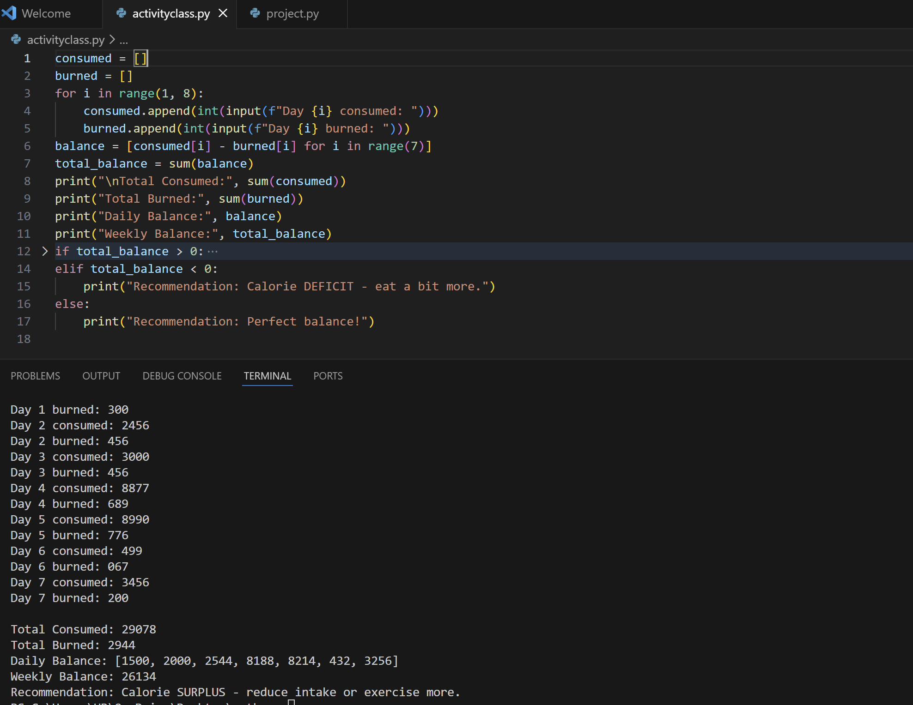

> Future Enhancement:-
1. Personalization
2. User engagement
3. Wearable device synchronization
4. Gamification

>Conclusion:-
It’s effective in helping to monitor health metrics and potential for future expansion.
~ Promotes Health and Wellness : The application successfully assists users in tracking their dietary intake and physical activity, which is crucial for managing weight and maintaining a healthy lifestyle. It empower individual to make informed decisions about their health.
~ User Empowerment and Motivation : The program helps users to set and monitor fitness goals, track their progress over time , and stay motivated.
~ Practical Applications of Programming Skills : For future development prospective ,the project serves as a practical example of applying Python Programming concepts (e.g., data handling with Pandas , file I/O ,and data visualization ) to solve a real- world problem.

>References :-
1. Lab manual provided by the department of Computer Science ,VIT-Bhopal.
2.Classroom lectures and faculty instructions.

